FEATURED TOPICAL

Venice teacher pens book on how COVID affected learning

'Does virtual school work?' is question that is tackled
- By SUE ERWIN Staff Writer
- May 28, 2022

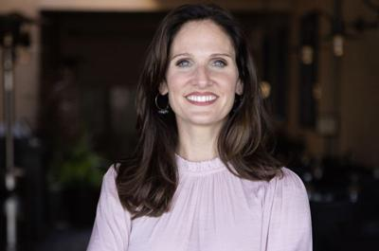
Lisa Richardson Hassler
PHOTO PROVIDED

VENICE — A Venice teacher published a new book recently focused on pre-and-post COVID reading proficiencies among third-graders.
Lisa Richardson Hassler released “America’s Embarrassing Reading Crisis: What We Learned from COVID,” which focuses on methods and theories placed within classrooms and homes, while blending them with strategies that work in today’s environment.
Richardson Hassler, a second-grade teacher at Epiphany Cathedral School in Venice, chose the topic for her dissertation five years ago as she sought her doctorate in educational leadership.
She decided the topic could benefit a broader audience.
“The book highlights the learning loss that took place nationwide during COVID, with an alarming study that focuses on third-grade reading proficiencies by comparing pre-established virtual learning methods with traditional brick-and-mortar,” Richardson Hassler said.
She said it was inspired by Michael G. Moore’s "Theory of Transactional Distance.” Moore is a professor emeritus in education deemed one of the "founding fathers of distance learning."
She spent the past several years researching the question: Does virtual school work?
“There were no relevant studies I could find on the topic for this grade level,” Richardson Hassler said. “We needed a statewide study on the validity of primary virtual education.”
Using surveys to interview teachers throughout the state, she tracked the progress of third grade students.
The study showed that nearly 44% of third-graders in Florida are not meeting reading proficiency goals, while other states across the U.S. share similar numbers, or worse.
What she found was both surprising and hopeful, she said.
"When done right, students in virtual classes outperformed in-class instruction and there was an 8% over-achievement rate."
Lisa Richardson Hassler, author of "America's Embarrassing Reading Crisis: What We Learned from COVID,"
“When done right, students in virtual classes outperformed in-class instruction and there was an 8% over-achievement rate,” she said. “The data has made it clear that we need to explore new tactics in order to bridge these drastic reading proficiency gaps and prevent further learning loss for our children.
“We now know that third grade is a critical period for a student’s short and long-term success. More than 80% of students who fail to earn a high school diploma were struggling readers in third grade.”
Richardson Hassler hopes teachers and parents incorporate the tips and methods she mentions in the book at home and in the classroom.
“America’s Embarrassing Reading Crisis: What We Learned from COVID” is available in ebook and print.
For more information, visit: drlisarhassler.com.

